**USFWS, Washington Maritime NWRC - Refuge Specific Survey Instructions**

**Tufted Puffin Monitoring (T1; Cooperative Baseline Monitoring)**

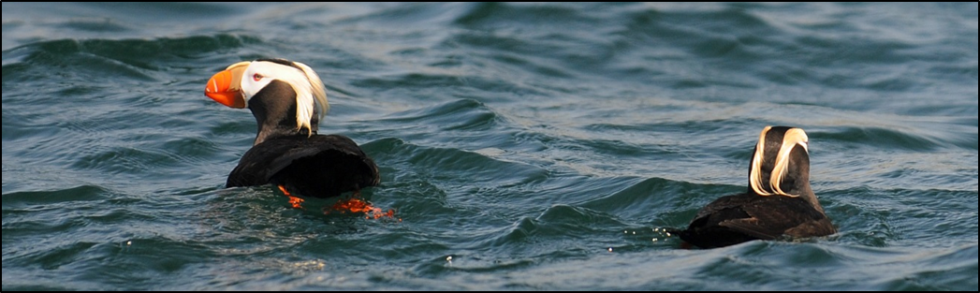

Sue Thomas, Wildlife Biologist

8/15/2019 Update

## Refuges

Quillayute Needles, Flattery Rocks, Copalis, San Juan Islands, Protection Island NWRs

## Primary Refuge Staff Contact Information

Sue Thomas, Wildlife Biologist, [Sue_Thomas@fws.gov,](mailto:Sue_Thomas@fws.gov) 360- 457-8451. Scott Pearson (WDFW Senior Research Scientist) and Peter Hodum, Associate Professor, PSU co-lead this effort including developing protocol, compiling and analyzing results. Refuge staff conduct surveys 1-3 times per year.

## Background

This survey is key to assessing the status and trends of Tufted Puffins (*Fratercula cirrhata*) on their breeding colonies within Washington State. The species is currently listed as endangered in Washington State and the USFWS is currently reviewing a petition for listing under the U.S. Endangered Species Act (ESA). During the past 15 years, population declines of 3-21 percent per year have been estimated for Tufted Puffins in CA, OR, and WA (USFWS 2005). Speich and Wahl (1989) estimated the population in Washington at 23,300 birds with as much as 50% more due to uncertainties associated with survey methodologies. However, surveys from 2007-2008 suggested the minimum population estimate in WA at less than 3,000 individuals with significant rates of decline recorded on pelagic surveys (Hanson & Wiles 2015). This downward trend may reflect a response to decadal changes in large-scale ocean currents and conditions. Because the species is highly dispersed throughout the north Pacific during the nonbreeding season, the best time to monitor them is during the breeding season, yet puffins nest in burrows that are difficult to access because breeding colonies are often located on unstable or inaccessible areas. As a result, accurate population estimates are lacking (USFWS 2005) which further hinders a clear assessment of the species status both within the state and the southern portion of their range. This survey is considered one of the highest Tier 1 priority surveys primarily because the refuges support the majority of puffin nesting in WA. In addition, there is some immediacy of need due to the recent listing in the State and petition to list it under the ESA.

Tufted Puffin colonies can be found from Japan to California with the majority in Alaska. This species is a true colonial nesting seabird that begins nesting at 3-5 years of age; they lay one egg per year. Their life span in the wild is unknown; however captive raised birds regularly live from 15-20 years. Adult survival has been reported at 92-95% (Hanson and Wiles 2015). This species will readily excavate burrows, but have also been known to nest in crevices and nest boxes. Breeding appears to be primarily regulated by the availability of forage resources.

Puffins are diurnally active with highest activity levels on colony occurring prior to 2 pm or after 8 pm based on observations on Tatoosh Island (Hodum, pers comm). Adults are most active feeding chicks in burrows between sunrise and 11 am while nonbreeders are typically active on colony a few hours after sunrise. In addition, nonbreeders are visible on colony (e.g. ‘ledge sit’) while adults with chicks will immediately enter the burrow and leave again (particularly later in the season) to continue foraging.

They commonly nest in burrows in Washington, often on a steep, inaccessible cliff or bluffs. Due the inaccessibility of burrow nesting habitat, wide dispersion during the nonbreeding season and lack of standardized monitoring protocols, an accurate population estimate has not been developed, range-wide. Yet, one key step in assessing the species for federal listing is to assess the population throughout the range. The Co-leads have developed and implemented the rapid assessment protocol since 2005. The data from these surveys have been applied to the State Status Assessment for the species. Rapid assessment surveys should be conducted from mid-July through August.

## Objectives

This cooperative monitoring effort meets several CCP objectives for 5 of the 6 refuges in this Complex. The majority of puffins are found along the outer coast of WA within Copalis, Quillayute Needles, and Flattery Rocks National Wildlife Refuges. Coordinated, comprehensive surveys meet the following objectives for these refuges: SS1 to continue coordination with others to monitor federally or state listed species; CP2 to continue joint surveys with WDFW, particularly TES; and RA2 to explore “low impact methods of determining population sizes of tufted puffin…at key refuge breeding colonies” (USFWS 2007). This last strategy is also identified within the Status Report for the Tufted Puffin (Hanson and Wiles 2015). This survey supports the Protection Island and San Juan Islands National Wildlife Refuges CCP objectives 1.3, 2.2, and 3.3, which identify the protection and maintenance of puffin burrow-nesting habitat as well as 9.2 and 9.3 to study or survey demographic parameters of puffins (USFWS 2011). In addition, this survey meets the following objectives of the Seabird Conservation Plan – Pacific Region (SCP; USFWS 2005): 1. Develop and implement standardized protocols for determining population status and trends as well as 2. Continue or initiate long-term monitoring at key colonies throughout the Region to track population trends.

* Assess changes in measures of tufted puffin breeding season activity (# birds on water, # circling, # entering burrows, etc.) as an indirect measure for assessing changes in the condition of Washington’s puffin population and as an indirect measure of annual reproductive success.

## Survey Area

The survey area consists of refuge islands that have supported puffin colonies in the recent past with the exception of Tatoosh Island (Makah Tribal land) in the interest of covering islands much further to the south, not typically surveyed (i.e. Willoughby and Erin). Specific islands include:

Table 1. Island name, location and supporting data for islands targeted for Tufted Puffin surveys.

|  |  |  |  |  |  |  |  |
| --- | --- | --- | --- | --- | --- | --- | --- |
| **Colony #** | **Island Name** | **Lat** | **Long** | **Survey Points (transect)** | **Recent Data (07-16)** | **Historic Data (78-86)** | **Dist. from Marina (nm)** |
| 174101 | Erin | 47.299948 | -124.267886 | nw, e | 0-25 | 15 - 200 | 40 |
| 174017 | Willoughby Rock | 47.410795 | -124.355032 | ne, s | 0-39 | 28 - 120 | 32 |
| 174016 | Destruction Island | 47.675503 | -124.491082 | n |  |  | 16 |
| 174010 | Alexander Island | 47.798066 | -124.506946 | n, s (w) | 6-460 | 45 - 4,000 | 8.5 |
| 174007 | Rounded Island | 47.830375 | -124.555002 | e, w (s) | 2-95 | 20 - 150 | 6.2 |
| 174041 | Petrel | 47.909994 | -124.650776 | wsw | 0-43 | 300 | 0.5 |
| 174002 | Cake Rock | 47.931929 | -124.684984 | n, s (w) | 0-74 | 70 - 1,000 | 3 |
| 155008 | White Rock | 48.135478 | -124.73257 | ne | 20 | 0 - 150 | 16 |
| 155059 | Bodelteh - West & Middle | 48.175858 | -124.763684 | n, s (w) | 0-71 | 0 - 380 | 20 |
| 155039 | Silversides | 48.251667 | -124.710517 | n, s (w) | 3-8 | 0 - 200 | 25 |
| 155010 | Carroll Island | 48.004778 | -124.723922 | ne, se, w (n) | 18-211 | 0 - 8,000 | 8 |
| 174027 | Jagged Island | 47.997224 | -124.695735 | n, s (w) | 1-768 | 0 - 12,000 | 8 |
| 174049 | Huntington & Cakesosta | 47.883567 | -124.638015 | nw, sw, e (w, s) | 0-78 | 6 - 1,100 | 1.5 |
|  |  |  |  |  |  |  |  |
| 156034 | Smith Island | 48.320933 | -122.846483 | w,s | 18-25 | 1-44 | 18 |
| 1560035 | Protection Island | 48.126695 | -122.931954 | nw, sw | 4-37 | 25-100 | 7 |

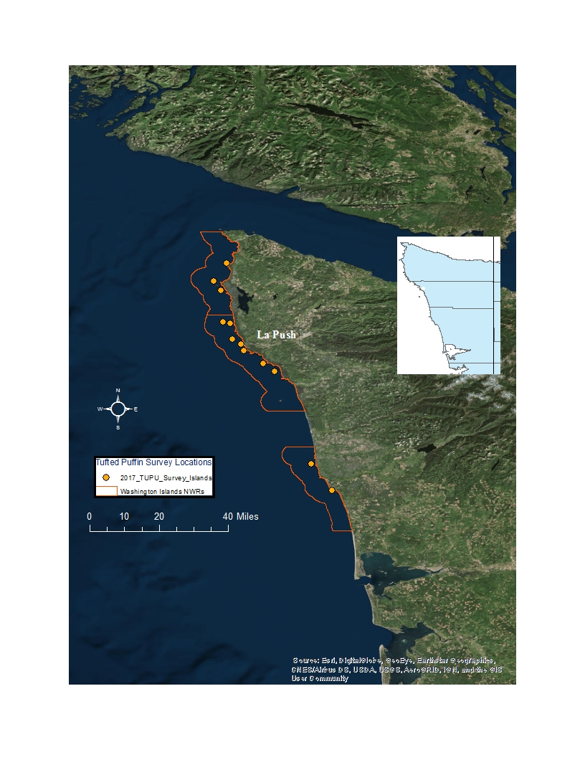

Figure 1. Map of colonies within Quillayute Needles, Flattery Rocks and Copalis NWRs.

## Methods

Surveys are conducted between May and September, with emphasis on the late incubation/early hatching period when adults are most active provisioning chicks (mid-July through August). Surveys will be conducted when conditions were suitable for observing birds with binoculars by boat (e.g. swell heights of 5 feet or less; period of 12 seconds or more, Beaufort Wind Scale <3 and wind waves of 1’ or less).

**Beaufort Wind Scale**

|  |  |  |  |  |
| --- | --- | --- | --- | --- |
| **Force** | **Wind (Knots)** | **WMO Classification** | **Appearance of Wind Effects** | |
| **On the Water** | **On Land** |
| **0** | Less than 1 | Calm | Sea surface smooth and mirror-like | Calm, smoke rises vertically |
| **1** | 1-3 | Light Air | Scaly ripples, no foam crests | Smoke drift indicates wind direction, still wind vanes |
| **2** | 4-6 | Light Breeze | Small wavelets, crests glassy, no breaking | Wind felt on face, leaves rustle, vanes begin to move |
| **3** | 7-10 | Gentle Breeze | Large wavelets, crests begin to break, scattered whitecaps | Leaves and small twigs constantly moving, light flags extended |

All surveys will occur between 06:30 – 14:00 each day with observation points set adjacent to suitable habitat (grassy areas with soil available for burrows) and transects run between points of suitable habitat noting puffins on the water, air or land. Observations will be made by a minimum of three observers on a 35’ Safeboat which will be maintained at a position within approximately 50-75 m off shore or further if puffin behavior is affected by the presence of the boat (e.g circling in flight for >10 minutes with no other disturbance in sight).

Rapid Assessment - The rapid assessment protocol developed by the Co-Leads for this project involves grouping observations into short (15 minute) observation periods at a point with periods in transit or moving between points (for larger rocks/islands). Indicate location of each observation point (e.g., just off “east side of Kanem Spit”) and the area covered while in transit (e.g., “Marina to Kanem Spit”). If a small rock indicate side for location N, NE, NW, W, E, etc. Record only new birds during each point or while in transit. Observation points are located within 50-75 m from shore unless reefs or shallow water precluded closer approach. Birds in the water are counted within 200 m of shore. Surveys in transit should be conducted at a speed of 5-7 mph. The number of point counts should be based on the number of locations needed to observe all sides of an island with suitable nesting habitat during counts. For example, because Protection Island is very large, there are four count points to cover the entire potential nesting habitat. For some islands, it is not possible to circumnavigate the island because of shallow water and exposed/submerged rocks. If only one side of an island has suitable habitat, then only spend time on that side of the island. In most cases, crews should be able to observe the entire potential nesting habitat from the water with the possible exception of the very top of the islands. On Smith Island we will conduct more intensive observations including plotting active burrows (adults delivering fish), photographing birds with fish and following the rapid assessment protocol under development every half hour. If adults are actively delivering fish regularly, decrease rapid assessments to every hour and focus on taking photographs and plotting active burrows.

During each visit, document the number of puffins on the water, flying and standing on the cliff face based on when it was first observed. The total number of puffins observed per visit will be the total number of birds observed flying, on the water and on the cliff face. Also record evidence of breeding including burrow entry or departure and birds carrying fish (see field form for this breakout).

If time allows, also record the following species observed either on the island or on the water:

* BLOY - Black Oystercatcher
* BRAC - Brandt's Cormorant
* BRPE - Brown Pelican
* COMU - Common Murre
* DCCO - Double-crested Cormorant
* PECO - Pelagic Cormorant
* PIGU - Pigeon Guillemot
* RHAU - Rhinoceros Auklet
* WGWH - Western/Glaucous-winged Hybrid
* BAEA - Bald Eagle (record adult and juvenile separately)
* CORA - Common Raven
* PEFA - Peregrine Falcon

Also note the following on the field form (attached):

* Island Name & #
* Date
* Observers
* Start/Stop Time
* Start/Stop Location (decimal degrees)
* Beaufort Wind Scale (see below)
* Temperature (http://www.ndbc.noaa.gov/station_page.php?station=46041)
* % Cloud Cover – 0 = 0%, 1 = 33%, 2 = 66%, 3 = 100%
* Precipitation – N = None, R = Rain, F = Fog, D = Drizzle
* Sea State – height of swell and period or wind waves in the Salish Sea (<http://www.ndbc.noaa.gov/data/Forecasts/FZUS56.KSEW.html>)

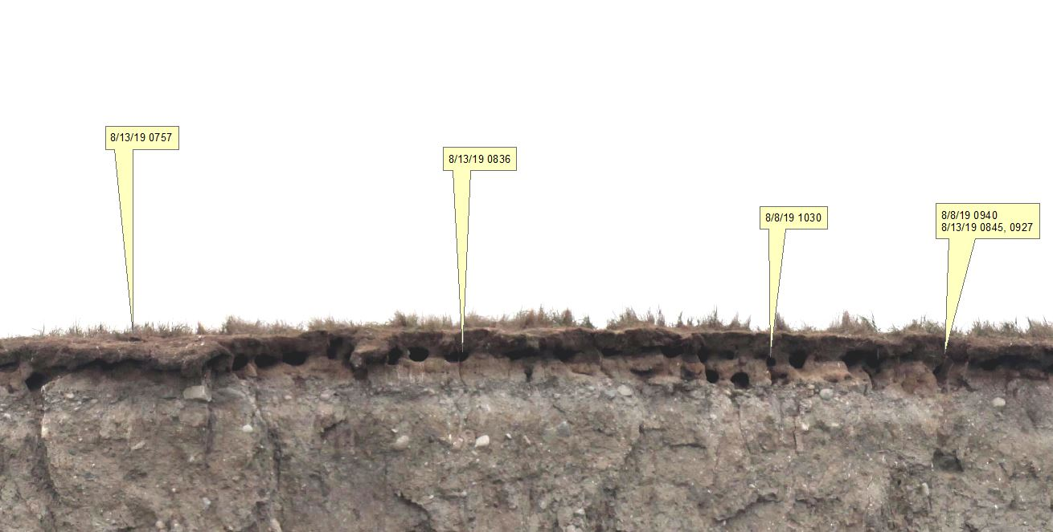

Burrow Mapping – This portion of the project will, by necessity, be restricted to a few islands each year (e.g. Smith and Destruction) due to the time required to comprehensively map burrows. Within one month of surveys, take *overlapping* photos of the survey area for burrow mapping. Photos with the horizon as well as the shoreline help observers located burrows on the photos. Be sure to record the lat/long of the boat at each photo point (e.g. two on the west end of Smith) to help in returning to that spot for observations. This in turn, will preserve the sight angles and aid in plotting burrows. Insert each photo into a Power Point document, number photos, adjust brightness to account for printer properties. Before printing, be sure to select ‘flip on short edge’ and check Printer Properties →Effects → Resizing Options, select ‘actual size.’ This will assure that the entire photo will be printed rather than cropped at the edges. Print two copies of all photos for recording burrow locations since multiple burrow entries will be observed by different people at one time and it is difficult to remember the exact location of a burrow while waiting for the map.

Diet Study – Due to time constraints, this portion of the study will be conducted on those islands selected for burrow mapping. The objective of this effort is to develop a database of forage resources fed to chicks. Capturing clear pictures of fish in the bill of a puffin in flight from a boat-based platform is challenging. The majority of the time, the birds will be at some distance as well, necessitating the use of a higher zoom setting. Below are the suggested settings for the Canon 5D Make II with 100-400 mm lens and recommendations to capture the best quality photos:

* TV (Shutter priority)
* Shutter speed as fast as possible (1/2500 or 1/3200) depending on light levels. The lower the light level, the slower the settings (e.g. 1/2500).
* ISO – 800-1250 (any higher and photos become grainy)
* AI Servo
* Image Stabilizer mode (on lens) set to Mode 2 (tracking moving subjects)

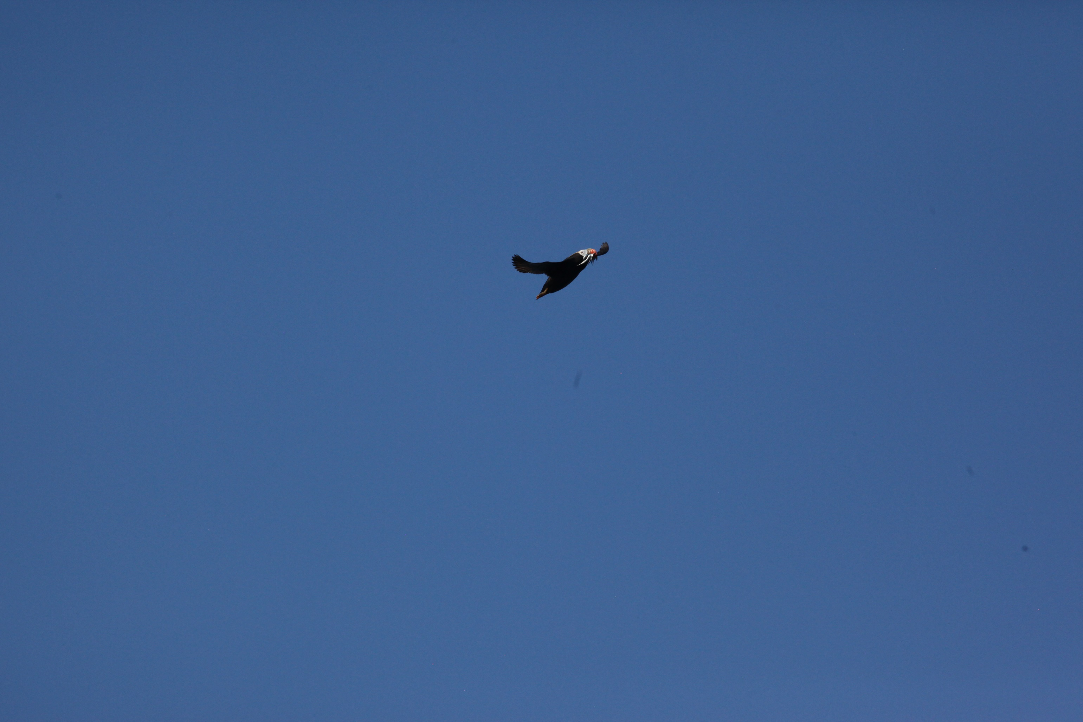

## Personnel

Sue Thomas, WMNWRC Wildlife Biologist, coordinates with the lead investigators and trains observers, conducts the survey, processes data, analyzes results, provides a report and archives data. Lorenz Sollmann, WMNWRC Deputy Project Leader, serves as the main boat operator and helps conduct the survey when sea state allows. Juliana Merluccio, WMNWRC Biological Science Technician, will assist when other projects allow.

## Impacts

Wildlife –Birds on shore or in the entrance to burrows do not appear to be affected by the boat stationed at approximately 50-75m from shore over the survey period other than moving away from the boat if in close proximity upon the start of the survey. Given the short time span for this survey at each island very little impact is expected. In addition, we will stay well away from marine mammal haul outs.

Habitat – We will not access refuge islands during this survey. The boat will maintain position offshore for short periods, thus impacts to aquatic habitat are expected to be minimal. We do not anticipate foraging seabirds will be displaced given the short survey period and area based on observations during a similar survey effort off Protection Island.

## Logistical Considerations

Conducting a comprehensive survey of WINWRs target islands is anticipated to take approx. 3 full days given good weather and 3-5 staff. Surveys off Smith and Protection islands each take ½ day. Because movement around the boat will be restricted with 4-5 staff, the minimal are preferred however, counts of other species might be restricted. Travel and boat gas are expected.

Permits & Animal Welfare Plan

No known permits are required. This is a passive survey with no access to the islands. No birds will be handled during this survey effort.

## Report

Raw data and an annual progress report will be provided to the Lead Investigators during the fall or winter following the survey. An annual progress report will indicate basic results of the survey including the number and map of active burrows as well as the number of individuals/species/activity/location (point or transect).

## Data Management and Analysis

Metrics: # of Tufted Puffins; # of islands with incidental data collected for other species observed on land or in the water. Data will be processed in Excel and Power Point, stored on the main server for the Complex office, backed up monthly onto an external hard drive and stored off site.

The Lead Investigators will compile data from all survey efforts, including those of their crew, and analyze. Results of analysis will likely be used to further refine the survey protocol.

## References

Hanson, T. and G. J. Wiles. 2015. Washington state status report for the Tufted Puffin. Washington Department of Fish and Wildlife, Olympia, Washington. 66 pp.

Landres N. 2013b. Final Draft - San Juan Islands Wilderness: A report on wilderness character monitoring. Sequim, Washington: USDI Fish and Wildlife Service; 76 p.

USFWS (U.S. Fish and Wildlife Service). 2005. Regional Seabird Conservation Plan - Pacific Region. Portland, Oregon: USDI Fish and Wildlife Service, Migratory Birds and Habitat Programs, Pacific Region. Available: <http://www.fws.gov/pacific/migratorybirds/PDF/Seabird%20Conservation%20Plan%20Complete.pdf>

USFWS (U.S. Fish and Wildlife Service). 2011. Protection Island and San Juan Islands National Wildlife Refuges - Comprehensive Conservation Plan and San Juan Islands Wilderness Stewardship Plan. Portland, Oregon: USDI Fish and Wildlife Service, Region 1. Available: <http://www.fws.gov/pacific/planning/main/docs/WA/docsprotectionIs.htm>

USFWS. 2007. Washington Islands National Wildlife Refuges – Comprehensive Conservation Plan and Environmental Assessment. Sequim, WA.

**Tufted Puffin Occupancy Field Survey Form** (5 July 2016)

Survey Location Name ______________________ Island number __________Month________ Day_____ Year_____

Observer (s) Name: _______________________________ Initials: _________

Observer (s) Name: _______________________________ Initials: _________

Observer (s) Name: _______________________________ Initials: _________

Observer (s) Name: _______________________________ Initials: _________

Start Time Stop Time Total Time

Starting Location: Ending Location: (DD, Lat./long.)

Beaufort Wind Scale: Temperature: Cloud Cover: Precipitation:

Sea State:_________________________________________________ Cloud Cover: 0 = 0%, 1 = 33%, 2 = 66%, 3 = 100%

Sea State: ht of swell, period Precipitation: N = None, R = Rain, F = Fog, D = Drizzle

Number of Tufted Puffins observed

|  |  |  |  |  |  |  |  |  |  |
| --- | --- | --- | --- | --- | --- | --- | --- | --- | --- |
|  | **Observer’s activity and location** | | **Puffin Counts by category** | | | | | | |
|  | **Moving/15 min obs** | **Location** | **On Water** | **Flying** | **Cliff Face** | **Burrow Entry/Nest** | **Burrow Exit** | **Carrying Fish** | **Total** |
| **1** |  |  |  |  |  |  |  |  |  |
| **2** |  |  |  |  |  |  |  |  |  |
| **3** |  |  |  |  |  |  |  |  |  |
| **4** |  |  |  |  |  |  |  |  |  |
| **5** |  |  |  |  |  |  |  |  |  |
| **6** |  |  |  |  |  |  |  |  |  |
| **7** |  |  |  |  |  |  |  |  |  |
| **8** |  |  |  |  |  |  |  |  |  |
| **TOTALS** | | |  |  |  |  |  |  |  |

**Observers activity and location**: Group observations into 15 minute observation periods (not moving) and the periods “moving” between 15 minute observation periods (for larger rocks/islands). Indicate location of 15 minute count (e.g., just off “east side of Kanem Spit”) and the area covered while “moving” (e.g., “Marina to Kanem Spit”). If a small rock indicate side for location N, NE, NW, W, E, etc.

**Puffin Counts**: Put bird in category when first observed. Number **O**n **W**ater, **F**lyingor on **C**liff **F**ace = total number of birds observed in each of these categories for each moving or 15 min observation period. Birds Flying that **E**nter or **E**xit **B**urrows also get a Burrow entry and exit count – yes this is a double count. **C**arrying **F**ish is the number of birds observed with fish in their beak from all of the previous categories. Row **T**otal = the total number of birds observed = Total on water + Flying + Cliff Face (no double counts!)

Counts of other Species (not flying unless first observed on surface or observed landing during the survey)

|  |  |  |  |  |  |  |  |  |
| --- | --- | --- | --- | --- | --- | --- | --- | --- |
| **Location** | **Species Code** | **On Water** | **Flying** | **Cliff Face** | **On Nest** | **On Rock/Island but not on nest** | **Carrying Fish** | **Total** |
|  |  |  |  |  |  |  |  |  |
|  |  |  |  |  |  |  |  |  |
|  |  |  |  |  |  |  |  |  |
|  |  |  |  |  |  |  |  |  |
|  |  |  |  |  |  |  |  |  |